A Report on

## INPLANT TRAINING AT

**E-Revbay Pvt Ltd.**

## Goregaon (East), MUMBAI – 400063.

Submitted By

**Anirbaan Ghatak**

## SAP ID: 70321019026

Under The Guidance Of

## Prof. Supriya Agrawal



**Shri Vile Parle Kelvani Mandal’s**

**Mukesh Patel School of Technology & Management Engineering**

## Department of Computer Engineering

**Vile Parle (w), Mumbai- 400056 Inplant Training Period 05/12/2022 to 31/05/2023**

## NO OBJECTION CERTIFICATE

This is to certify that **Anirbaan Ghatak** (SAP ID. **70321019026**) student of Mukesh Patel School of Technology Management & Engineering, has successfully completed his Semester (**VIII**) Inplant Training from **05/12/2022 to 31/05/2023**, at **E-Revbay Pvt. Ltd.** and has completed the tasks given to him during the Inplant Training. The Report is submitted in partial fulfillment of the requirement for B.Tech Integrated **Computer** Engineering. He has been allowed to include the relevant information from the Company for which we have no objection.

Signature & Stamp of The Industry

## CERTIFICATE OF SUBMISSION

This is to certify that the report entitled ‘Inplant Training at **‘E-Revbay Pvt Ltd’** is a bonafide work of **Anirbaan Ghatak** (SAP ID. **70321019026**) and submitted in semester (**VIII)** for the partial fulfillment of B.Tech Integrated in **Computer** Engineering at , Mukesh Patel Schoolof Technology Management & Engineering Mumbai during the academic year 2022-2023.

Signature:

Faculty Mentor B Tech. Integrated Incharge B Tech. Integrated Director

### DECLARATION

I, **Anirbaan Ghatak**, SAP ID. **70321019026** a student of Semester (**VIII**) of B.Tech Integrated Program in EXTC engineering humbly submit that I have completed from time to time the Inplant Training work as described in this report by my own skills and studied **from 05/12/2022 to 31/05/2023.** I have not copied the report or it’s from any appreciable part from any other literature in contravention of academics ethics. I declare that this written submission represents my ideas in my own words. I also declare that I have adhered to all principles of academic honesty and integrity and have not misrepresented of fabricated or falsified any idea/data/fact/source in my submission. I understand that any violation of the above will be the cause of disciplinary action by the Institute and can also evoke penal action from the sources which have thus not been properly cited or from whom proper permission has not been taken when needed.

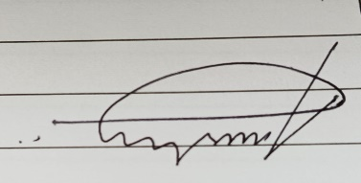

Date: 24/02/2023

Place: Mumbai Name & Signature of the Student

### Cover Page

* **No Objection Certificate**
* **Certificate of Submission**
* **Declaration**

|  |  |
| --- | --- |
| **Table of Contents** | **Page No.** |
| **Chapter-1**   * **Introduction about the Company**   **(Background of the Industry), Products, Services & Solution etc.**   * **About the Department** | **1** |
| **Chapter-2**   * **Brief about the Technology/Equipment/ Hardware etc.** * **Brief about the Programming languages/ Tools/ Software etc.** | **2** |
| **Chapter-3**   * **Brief about the Projects undertaken** | **3** |
| **Chapter-4**   * **Learning In the Inplant Training** | **4** |
| **Chapter-5**   * **Conclusion & Future Plan of Action** | **5** |

# Chapter – 1 Introduction

## Introduction to the company

ERB is a Fin-Tech company that is disrupting the traditional financial services industry in India with its innovative B2B2C business model. By empowering its partners to offer a broad range of financial products, including credit cards, insurance, investments, and loans, ERB is making these services more accessible and user-friendly for customers across the country.

The company's mission is to simplify the complex processes that make up financial products and services, allowing customers to make informed decisions about their financial future. To achieve this, ERB has developed a proprietary technology stack, which includes a robust end-to-end CRM tool that helps partners and customers manage their financial needs seamlessly.

ERB takes pride in its long-standing relationships with major banks and financial institutions, which allows the company to provide a diverse range of financial products and services. However, what truly sets ERB apart is its family of financial service partners and its small, driven, and passionate team, who are working together to change how India consumes financial products, one day at a time.

With a deep understanding of the financial industry and a commitment to leveraging technology to make it more accessible, ERB is poised to revolutionize the way financial products and services are consumed in India. By putting customers at the forefront of its business model, ERB is driving a paradigm shift in the industry, one that is focused on making financial products and services more user-friendly, transparent, and accessible for everyone.

## About the Department

I worked in the heart of ERB the Tech department, ERB's tech department is a critical component of the company's success. With a focus on innovation and leveraging technology to simplify complex financial processes, the department plays a key role in developing and maintaining the company's proprietary technology stack. The tech department is made up of a talented and experienced team of developers and engineers who work together to ensure that ERB's technology is always cutting-edge and ahead of the curve. Their commitment to innovation and user experience helps ERB stay at the forefront of the rapidly evolving Fin-Tech industry in India.

# Chapter – 2 Problem Statement

## Brief about the technology used

ERB is a Fin-Tech company that relies heavily on technology to deliver financial products and services to its customers. Two key technologies used by ERB are TML and TMP. TML, or Test My Loan, is used to determine a customer's eligibility for a loan and provides recommendations for debt restructuring if needed. TMP, or Test My Policy, is used to evaluate a customer's current insurance policy and suggest upgrades if necessary. Both TML and TMP can be accessed through the FINQY website or app, which is provided to partners to help their customers. Customers can also access these technologies directly through the MLB platform.

ERB's use of cutting-edge technology allows the company to provide a wide range of financial products and services to its customers in a streamlined and efficient manner.

## Software used

ERB is a Fin-Tech company that relies heavily on technology to deliver financial products and services to its customers. ERB also uses the LAMP (Linux, Apache, MySQL, and PHP) web stack, which is known for its flexibility and scalability, to develop and maintain its web applications. In addition to its proprietary technology stack LAMP, ERB also leverages Microsoft Power Automate and Power BI in its operations. Power Automate is a workflow automation tool that allows ERB to streamline its internal processes, while Power BI provides the company with powerful business analytics and reporting capabilities. By using Power Automate and Power BI alongside its existing technology stack, ERB is able to optimize its operations, improve data analysis and decision-making, and provide an even better customer experience.

In addition to its existing technology stack and Microsoft Power Automate and Power BI, ERB also leverages Python and its module Selenium for web scraping. Web scraping enables ERB to gather data from various sources on the internet. By leveraging this data, ERB can gain insights into market trends, customer behavior, and other factors that can inform its product development and marketing strategies.

Furthermore, ERB also utilizes the Python library Pandas to create Excel spreadsheets from JSON data. In one instance, ERB used Pandas to convert an Equifax report, which contained valuable customer credit data, from JSON format to Excel. This enabled ERB to analyze the data more easily and make more informed decisions about its products and services. The use of Python and Pandas has allowed ERB to automate the data conversion process and reduce the time and effort required to analyze data, which is essential in the fast-paced Fin-Tech industry.

By integrating these technologies into its existing technology stack, ERB can stay ahead of the competition, remain agile, and provide the best possible customer experience. With the ability to gather and analyze data quickly and efficiently, ERB can make informed decisions that allow it to continue innovating and delivering cutting-edge financial products and services to its customers.

# Chapter – 3

**Brief about the Projects undertaken**

**Credit Analysis Report**

During my time at ERB, I gained a wealth of knowledge and experience in the financial technology industry. My first project involved automating the credit analysis report, which allowed me to develop my skills in programming languages like Python and Flask Framework. Where I developed the Authentication part of the website with the help of firebase which is a backend-as-a-service. I also helped in creating the main credit report website’s CSS. I was a part of the deployment team, which helped in deploying the website on azure web app service which is service provided by azure to deploy a website on the cloud. I was able to understand the importance of automation and how it can improve efficiency and accuracy in reporting.

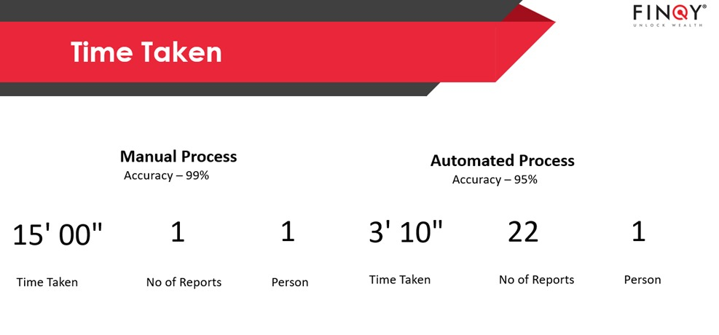

Speed of the Credit Analysis Program

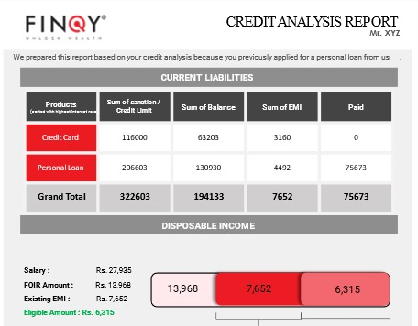 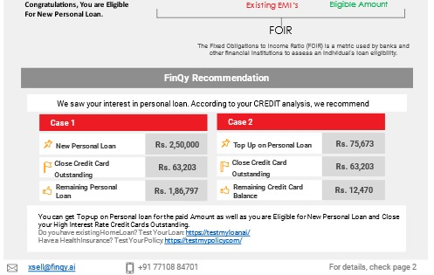



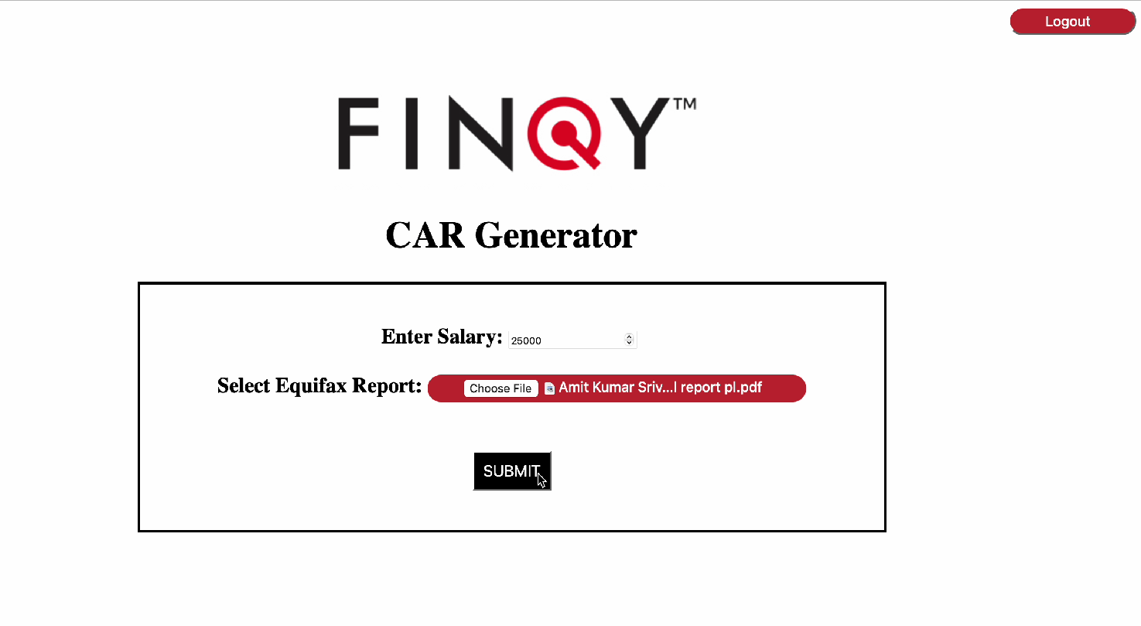

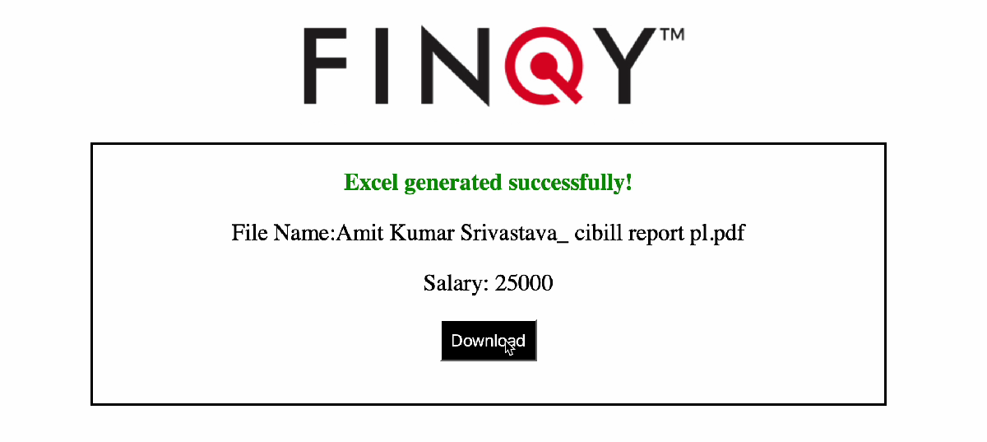

**Robotic Process Automation**

In my next project, I learned about the importance of testing and bug-fixing as I corrected the Power Automate program used for PNB bank's insurance completion tracking website. The RPA had a This taught me the importance of paying attention to details and the need for thorough testing to ensure smooth functioning of the system.

**Data Verification**

My experience in the Data team allowed me to learn about the importance of data verification and the various tools that can be used to do so, including Microsoft Power Automate. Which was used to run an RPA which checks if the number is on WhatsApp or not. Although my attempt to use Power Automate on virtual machines to verify WhatsApp numbers was unsuccessful. Later the power automate was replaced with a python code which was also an RPA as power automate proved to be a bit slower was again tasked to run this on the virtual machine but it also proved to be slow. This allowed me gain a deeper understanding of the limitations and challenges that arise when working with complex systems.

**Car Pe Loan**

The Car Pe Loan team tasked me with the job of scraping car valuation websites in order to assess costs. A couple of ways were approached the first being searching for used cars online and then access the cost this method was deemed as slow are it took a lot of time, we then shifted to using car valuation website which helped us provide detail in a more organized manner. Later we pursued the path of asking the companies which provided car valuation to give us an API to integrate it and streamline it, attended a couple of meetings with the respective companies which helped us get quotes and understand the market of used cars, it was helpful to us in conducting research on the present market for used cars.

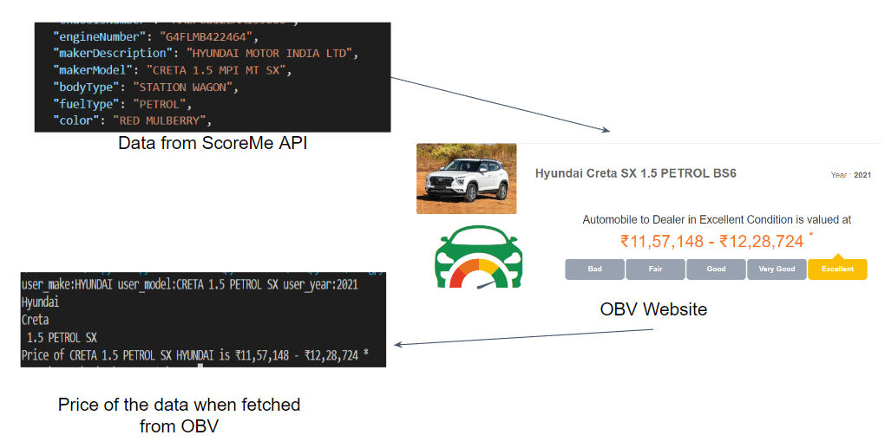

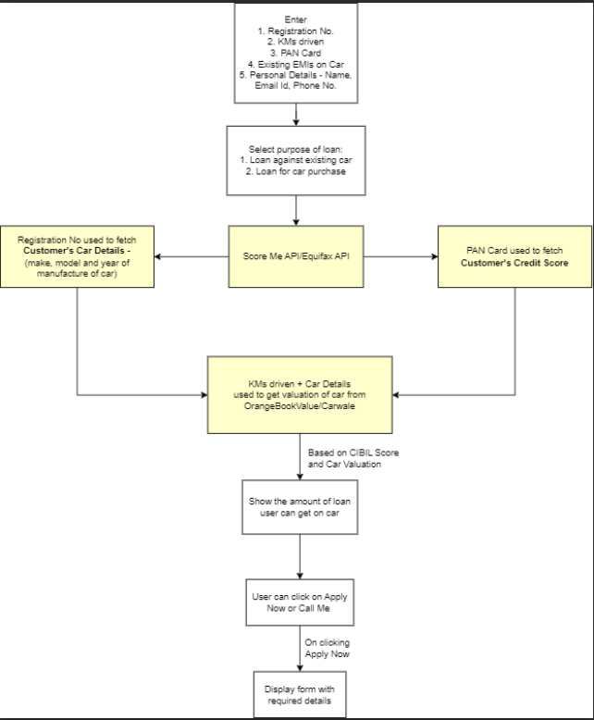

**Test My Credit Card**

I was tasked in helping to create the code which was used to for scraping the credit card details from the internet. Then came the stage of Cleaning the data which was fetched so that it was in a form that could be read by the code written for it. I was also later tasked with determining the monetary value of credit card reward points. I did this by evaluating data obtained through web scraping. Because of this, I was able to assist my colleague in creating TMCC’s recommendation system.

**MLB-TML**

In addition, I was assigned for generating a clubbed report of MLB-TML in order to assist customers with their various lending requirements. I was given the JSON format of Equifax report and tasked with making a excel as a part of the first phase where I used python to read the JSONs and pandas to analyze and convert it into a presentable and understandable excel. the next phase would be of converting these excels in a more attractive way in the form of an PDF, so customers would able to lessen the financial strain of their debts by moving the balances of their accounts thanks to this report. In addition to this, I reworked the code that was built for MLB-TML so that it could output Excel files containing Equifax information in JSON format. This made it possible for other departments to do customer research more effectively and come to judgments that were better informed.

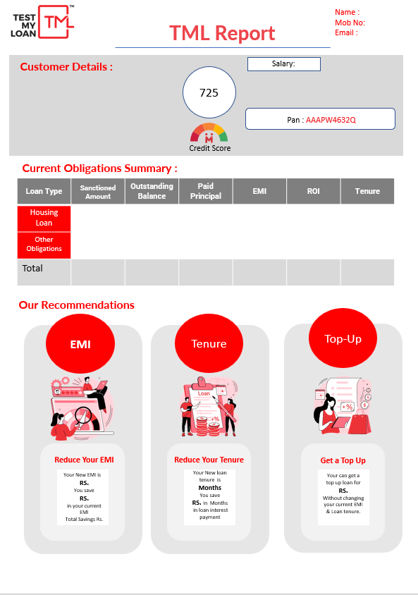 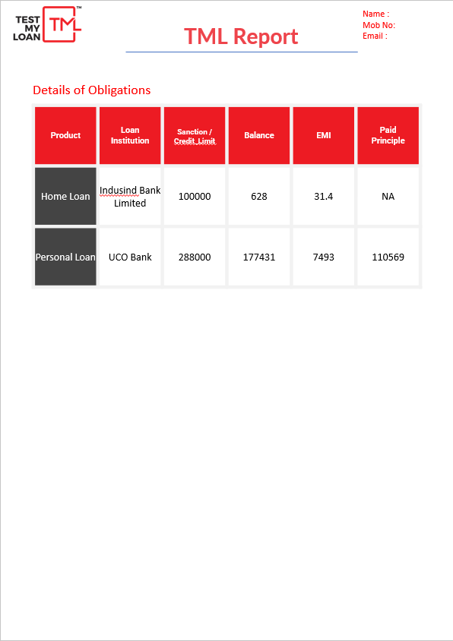

**Partner Verification**

In addition, I aided my colleague with partner verification by building code that retrieved the identities of specific individuals based on the collected content. This was done so that we could verify our partners. Optical character recognition technology was utilized to accomplish the extraction of this text from the necessary verification documents. The verification process became more efficient as a result of the automation's streamlining and simplification.

**Dashboard**

Along with MLB-TML I am currently helping in creating a Dashboard on power bi which will further help the department to see and access the Equifax JSON excel files

I was able to contribute to the development of ERB's financial products and services while also gaining useful experience utilizing my technical knowledge in real-world scenarios. In total, this was a very beneficial experience for me.

# Chapter – 4

**Learning in the inplant training**

I was fortunate to have a range of experiences that allowed me to learn and grow as a professional. My work on the credit analysis report automation project was one of the highlights of my internship. I used a combination of programming languages, including Python and HTML, as well as frameworks like Flask and CSS to automate the report, which proved to be an invaluable experience in understanding how automation can be used to improve reporting efficiency and accuracy. It also provided me with a deeper understanding of how reports are produced and delivered to clients, which is crucial knowledge in the financial technology sector.

Another significant project I worked on was fixing bugs in the Power Automate program used by PNB Bank's insurance completion tracking website. I learned about the functioning of RPA software’s and how eliminate menial work using RPA, and importance of meticulous testing and attention to detail in ensuring the accuracy of complex systems. It was an invaluable experience that taught me how to identify and resolve technical issues.

As a member of the Data team, I gained valuable knowledge about the significance of data verification and the various technologies used to validate data. While working on the WhatsApp number verification project using Power Automate on virtual computers, I learned about the challenges associated with this approach, which helped me to develop an understanding of critical and logical thinking by having the dilemma of which part to give more importance scalability or speed.

I was introduced to website scraping methods, market research techniques, and data analysis tools while working with the Car Pe Loan and Credit Card teams. For the Car Pe Loan team, I helped to scrape car valuation websites to estimate the cost of used cars, which taught me effective market research and data analysis techniques. In the Credit Card team, along with web scraping cleaning of excel data for better understanding for the code to run gave an interesting insight on how data must be presented for the machines to work also estimating the monetary value of credit card reward points, taught me the importance of linearity which helps in simplifying credit card recommendations.

Attending the Car Pe Loan meetings with car valuation companies about API’s helped me gain valuable communication and presentation skills which help me convey the needs of the project.

One of my most interesting tasks was creating a bundled report of MLB-TML to help customers with their lending requirements. This report enabled customers to reduce their financial burden by shifting their balances. This project taught me the structure of Loans and how to manipulate them to reduce tenure or rate of interest along with how to present data in a concise but informative manner. Additionally, I rewrote the code base used for MLB-TML to produce Excel files containing Equifax information in JSON format, which made it easier for relationship managers to conduct efficient analyzation of customer and suggest them what is best for them to reduce their debt.

Finally, I assisted my colleague with partner verification by writing a code which helped in fetching the names of the partners from the extract content which is used verification. This taught me how to optimize and simplify processes, as well as how to organize and cleanse data.

Overall, my internship at ERB was a fantastic opportunity to apply my technical skills in real-life situations while also contributing to the development of financial products and services. I am grateful for the opportunity to have worked with such a talented and supportive team, and I am excited to see where my newfound skills and knowledge will take me in the future.

# Chapter – 5

# Conclusion

I gained valuable financial technology industry knowledge and experience. Using Python, Flask Framework, HTML, and CSS, I automated the credit analysis report for one of my most significant initiatives. This project enabled me to expand my knowledge of programming languages, and I was able to witness firsthand how automation can enhance reporting efficiency and precision. In addition, it helped me comprehend how reports are created and presented to clients.

I also fixed bugs in the Power Automate program used by the PNB bank's insurance completion monitoring website. I had to pay close attention to the smallest of details and conduct exhaustive testing to ensure that the program delivered accurate results and that it ran efficiently. This endeavor taught me the significance of testing and the need to pay close attention to the smallest of details in complex systems.

As a member of the Data team, I gained knowledge of data verification and the various instruments used to verify data. Although the attempt to use Power Automate on virtual machines to verify WhatsApp numbers was unsuccessful, I gained a greater appreciation for the constraints and difficulties inherent in working with complex systems like the virtual machines hosted on the cloud.

Participating in the Test My Credit Card team taught me web crawling techniques and the significance of data collection and analysis. I learned how to extract data from web pages using tools such as Selenium, as well as how to manipulate and analyze the extracted data using Python. In addition, I was tasked with determining the monetary value of credit card reward points, which taught me the importance of effectively evaluating data.

In addition, I worked for the Car Pe Loan team, where I was tasked with scraping car valuation websites to determine the prices of used automobiles. This endeavor taught me how to conduct effective market research and data analysis to determine costs. Participating in Car Pe Loan meetings with car valuation companies about APIs enabled me to acquire valuable communication and presentation skills that assist me in communicating the project's requirements.

Creating a clubbed report of MLB-TML to which can assist consumers with their loan requirements helped me understand the financial jargon, structure of different types of Loans and how can they be manipulated to reduce interest and or tenure. In addition, I modified the code developed for MLB-TML to output Excel files containing Equifax information in JSON format, making it simpler for other departments to conduct effective customer research and provide them the best recommendation regarding their finances.

Lastly, I assisted a colleague with partner verification by writing code to retrieve the identities of individuals based on the collected content. The collated data was extracted using optical character recognition technology, which accelerated and simplified the verification procedure. This endeavor showed me how to simplify processes and maintain and cleanse data.

Overall, my time at ERB was extremely beneficial to me. I was able to contribute to the development of financial products and services while obtaining valuable experience applying my technical expertise in real-world settings.

### CERTIFICATE OF INPLANT TRAINING

This is to certify that Mr. Anirbaan Ghatak

SAP ID. 70331017003 of **VIII Semester** of B.Tech Integrated Program Computer

/EXTC/Civil/Mechanical has attended the Inplant Training for days out of at E-Revbay Pvt Ltd. during the Period: from 05/12/2022 to 31/05/2023.

**Signature of the Student Signature of the Industry Mentor**



Forwarded with compliments to the HoD for necessary action.

The details of working at organization:

Present: Days Leave: 3 Days Absent: 7 Days

Total: 147 Days